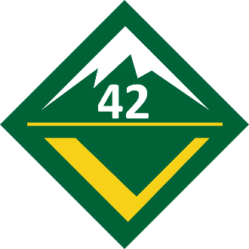
Training Requirements for the Venturing Award

Crew 42 Venturers,
There are four requirements required to complete your first rank in Venturing, known as the Venturing Award, listed below.
- Participate in a crew activity outside of a crew meeting
- Participate in an interview conducted by your crew president and your advisor
- Complete Personal Safety Awareness Training
  - https://www.scouting.org/programs/venturing/training/alps-youth-training/
- State intention to join the crew during a crew induction ceremony

Crew 42 respects the privacy you have with your parent and has requested you complete requirement #3 with your parent at home. Upon completion of this training session, you should bring this completed form to the interview required as part of requirement #2, at which time the requirement will be signed off in your book. If you have any Crew-specific questions, you may bring them up in the interview, but are not required to do so.

We, the undersigned certify that Venturing Award requirement #3 was completed in accordance with the instructions provided to us by BSA.

________________________________ ________________________________
Venturer (Please Print) Parent (Please Print)

________________________________ ________________________________ __________
Venturer Signature Parent Signature Date

